# **Design Journey Map: Milestone 1**

Use this design journey map to plan your project and to track your progress as you complete your milestones. This document is intended to help you plan and document the process. Document this process in the way that works best for your group. That means that if you prefer written paragraphs, use them. If you prefer bullet points, use them. This document exists to help you, make it your own to suit your group’s needs.

Group Name: Yellow Rooster

Team Member Names: Aleksandr Itskovich, Ji Hwan Seung, Wenyu Ding, Adrian Lim

Team Member NetIDs: ai223, js2687, wd87, ahl85

Lab Section Number: 213

## **Milestone 1, Part 1: The Client – know your client and users**

**Client** – In this part, tell us about your client (who is your client, what kind of website do they want built, what are their key goals). List at least 3 important goals. Make sure you explain why each of the goals is relevant.

The client is Summerhill Brewery, a family-owned and operated, new craft brewery in Summerhill, NY. Because it is a small business, they haven’t had the resources or knowledge to create a high-level, stylish website. Their current site (*https://www.summerhillbrewing.com/beers*) was made using Wix, a platform they found difficult to use, and they are unsatisfied with what they have been able to produce. They want a website with more features, better styling, and greater overall appeal than what they currently possess. They have a few key goals for their site:

* To convey clear and easy-to-find logistical information about where the brewery is located and what its hours of operation are; this is essential in driving new business to the website and keeping customers in the loop.
* To create a platform that music, food and other vendors, as well as potential employees and customers can use to contact the brewery owners; this is important for making new business contacts and expanding the brewery. I.e. making the website a communication point.
* To give new customers an idea of what the brewery is like, using features like menu and photo pages, with the intention of making the brewery seem like an appealing place to visit; this helps interest new customers in visiting the brewery and increasing business.
* Adding a sales page where customers can potentially buy brewery-affiliated merchandise like t-shirts or coasters; this would help increase revenue to the business.
* To provide information about the business and history of the brewery, including their business philosophy (e.g. using solar-energy, organic farming techniques) and mission statement.

*URLs of existing site:*

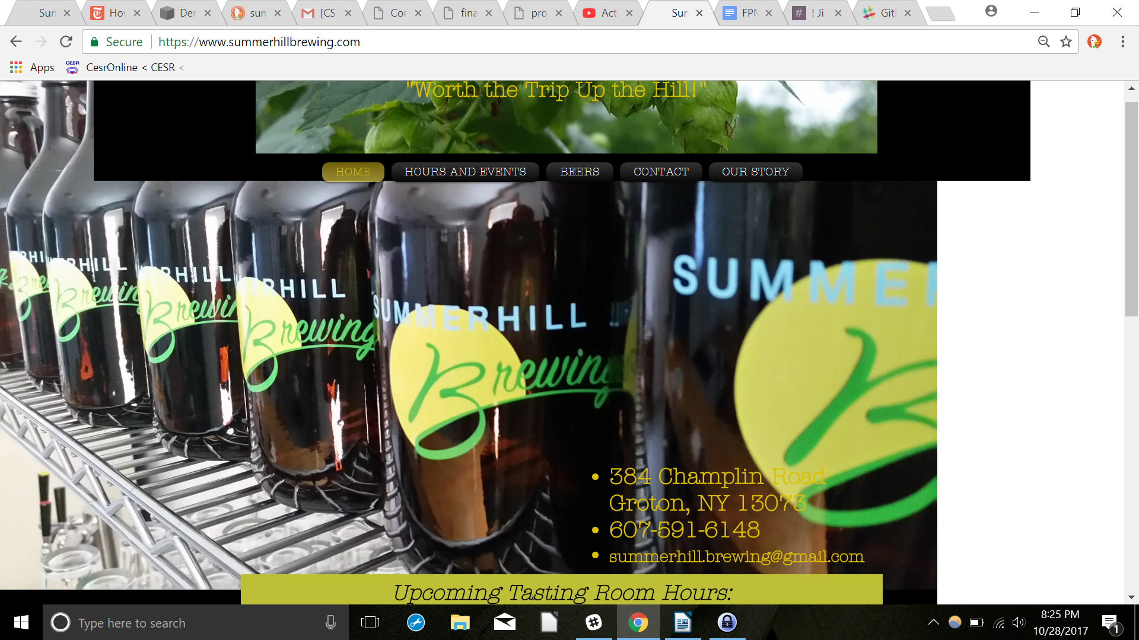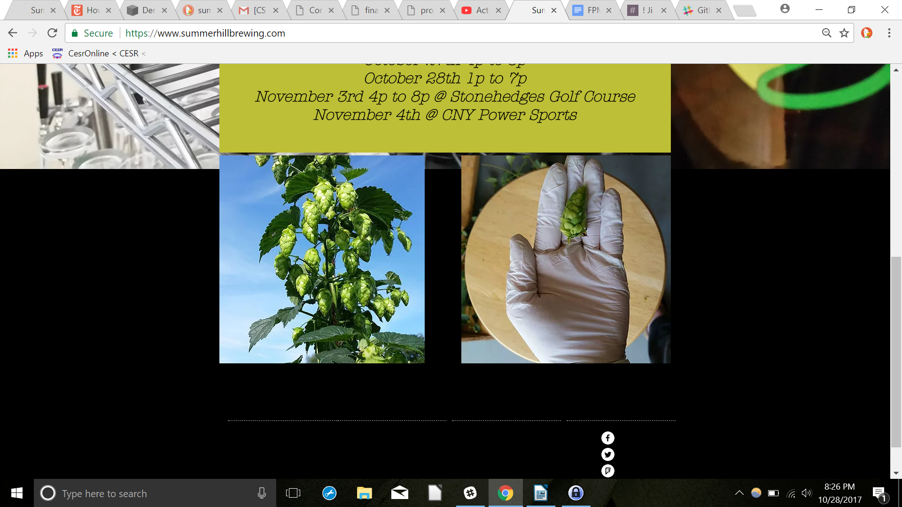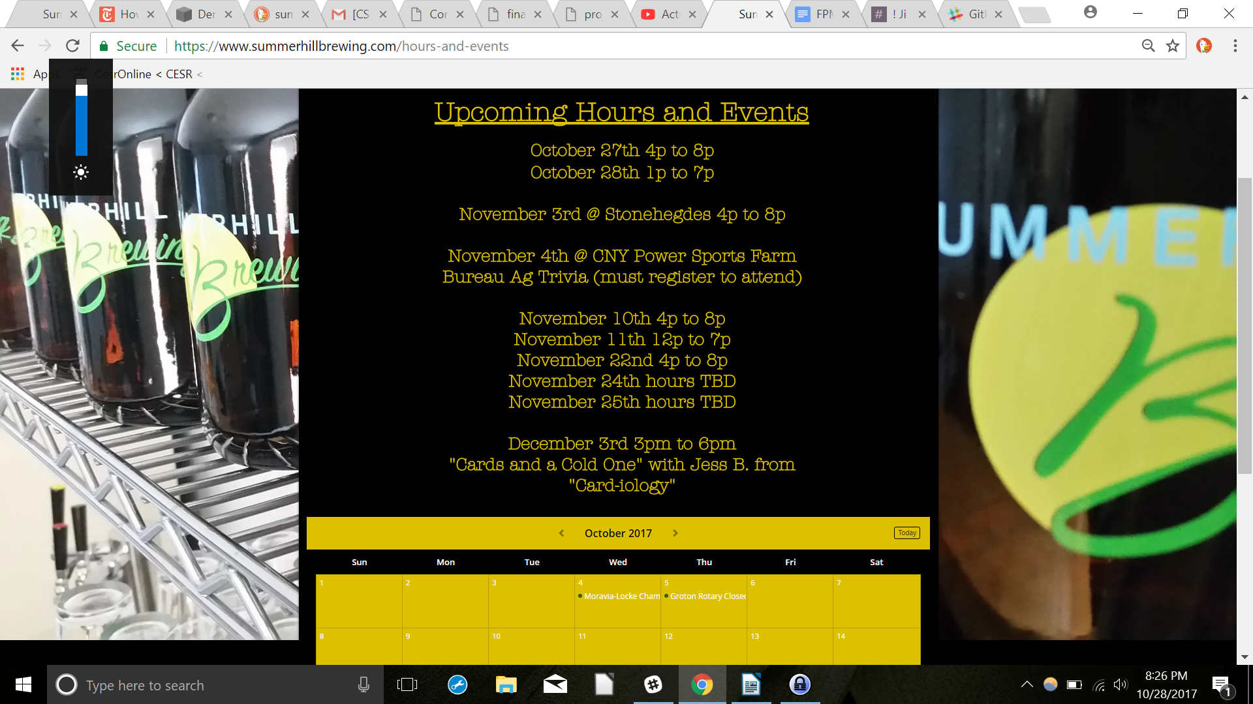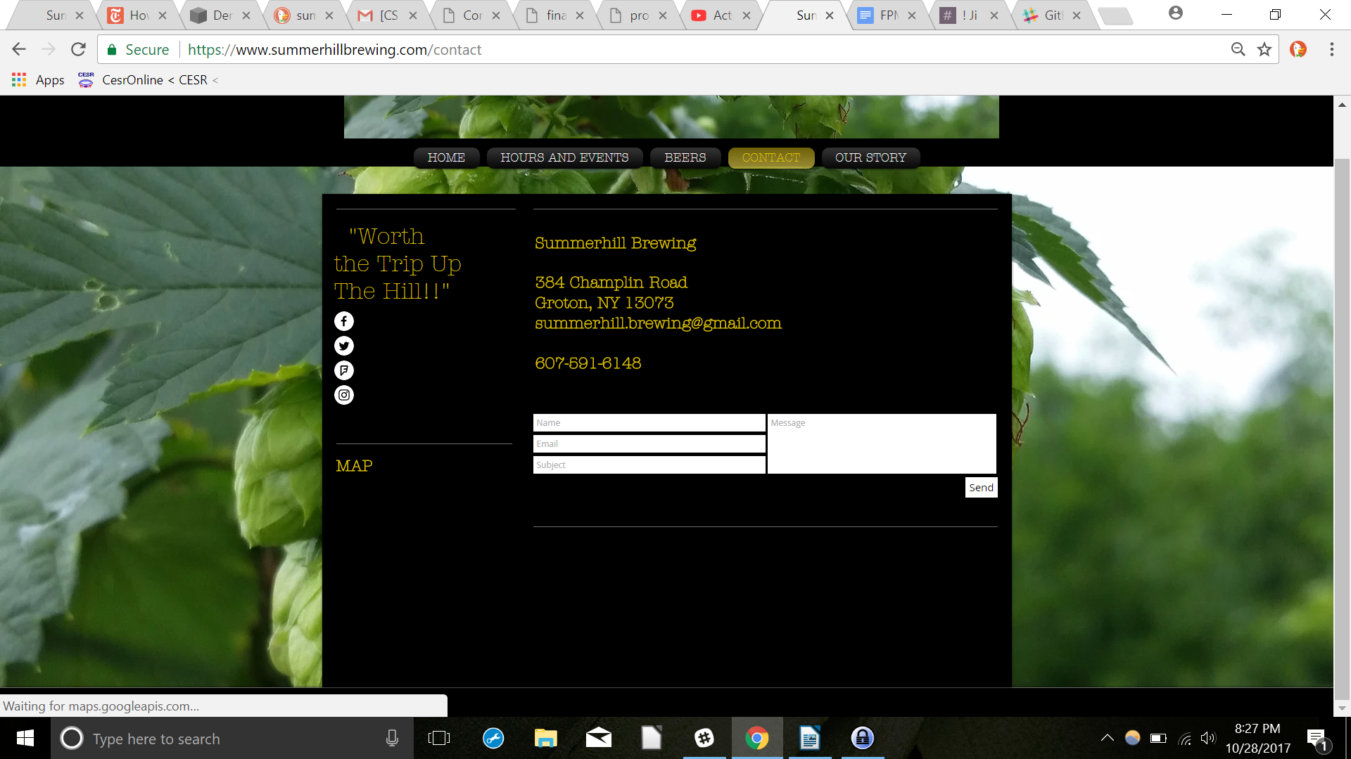

**Note**: If a website exists already, and you'll be redesigning it, then add the URL & screenshots of the existing site.

## **Milestone 1, Part 1: The Client – Target Audience**

In this part, tell us about who would be the potential consumers of this website, how, when, and where they’d interact with the website, etc. List at least 3 scenarios where they would use the website. Get as much detail as possible from the client to help you find representative users that can help you generate useful personas.

Craft brewing has exploded in popularity over the last few years. The Finger Lakes Region, already known for its young wineries, has recently been gaining a reputation for its breweries as well, making this a popular area to visit for people who like to try and drink beer. This means there is a wide base of potential consumers for this website, encompassing both people living in the Cayuga Lake region, as well as out-of-town and summer visitors. This category can include everyone from students that have come to the area for university study, to their visiting parents, to tourists that have heard good things about the local wine and beer scene. Locals, usually in their 30s to 50s, tend to visit the bar year round, while the summer months see a younger demographic, people in their 20s, visiting the brewery as well. Because the brewery is so young, it stands to reason that the demographics will change and expand as the business changes and grows. The website design should try and anticipate such changes.

Potential consumers would interact with the website when they would need to find out when the brewery is open for tasting/drinking. Currently, the bar and the brewery-area exist in a shared space, so the brewery does not have constant hours. It is therefore extremely important for consumers to be able to see when the brewery is open, and plan accordingly. Additionally, the brewery often travels to sell their beer at regional events, like sport games or concerts, so it’s important that consumers know where the brewery is going to be. Consumers who have never been to the brewery before would use the website to get a sense of what the brewery is like, and what it offers, before deciding on going.

*A few website-use scenarios:*

* A user would access the website to know if the brewery is going to be open on a given day
* A user would access the website to find out what kinds of beer the brewery is currently offering, including seasonal specials (e.g. the Pumpkin Spiced Ale)
* A user would access the website to find out where the brewery is located, and to get detailed directions on how to get there, since it is actually in a hard-to-find area (even FedEx trucks get lost on the way)
* A user would access the website to buy merchandise, like t-shirts or coasters, if they are fans of the bar
* A user would access the website to learn more about the brewery, and get a sense of what it is like before deciding on whether or not to visit
* A user would access the website if they were interested in selling food or performing at the brewery on a given evening
* A user would access the website to see if there were any job openings in the brewery staff
* A user would access the website to get the latest updates on the brewery, including news about expansion, press releases, etc.

## **Milestone 1, Part 1: The Client – Personas**

In this part, create two (or more, if needed) personas that represent different aspects of the client’s target audience, and describe them in detail below, e.g., demographics, appearance, characteristics, hobbies, etc. Make clear what kinds of people you talked to and researched, and what aspect of the target audience each persona relates to.

**Persona #1:** A woman in her mid-50s living in Groton, NY in the vicinity of the brewery. She lives and works on her own family dairy-farm. She is 5’3”, large-bodied, with shoulder-length, dyed-brown hair and wears simple, bright clothing when she goes out. Although this upstate region is growing in popularity and attracting new business, the Sunhill Brewery is still one of only local places where people can gather and enjoy themselves in this area. She loves to come to the brewery, often with her husband or with a friend, whenever the brewery is open (every other weekend, and on special occasions). She is on friendly terms with the bar-owners, and is also talkative with other bar patrons. As mentioned previously, there is not much to do in the area. When she is not busy with farm-work, which is very time consuming, her hobbies include shopping (especially in larger areas like Ithaca or even Binghamton). She also really enjoys baking. Her favorite season is Summer, when the weather is good and there are more activities and it is easier to get around. Person #1 represents the portion of the target audience that is comprised of people who live in the vicinity of the brewery (in or around Summerhill, NY) and patronize the bar on a regular or semi-regular basis.

**Persona #2:** A young man who comes from NYC, but is currently going to college in Syracuse, and is driving through the Finger Lakes beer trail with some roommates/friends, having heard about all the craft breweries opening in the area. He heard about Summerhill Brewery, along with other locations, at the Ithaca Beer Company and decided to check it out. He programmed the address into his car’s GPS, but then had trouble finding the location. He ended up calling the brewery and getting some more specific directions from the owners to find his way. He is really fond of craft beer, and has even tried brewing his own beer at home to mixed success (finding it hard to keep the beverage from becoming contaminated). At the same time, he’s not super particular about the beer he drinks and is mostly interested in having an enjoyable time with his friends. He is majoring in environmental studies, but is considering switching over to chemistry, which he really enjoys to the point of considering PhD programs. He is on the shorter side, wears loose, casual clothes and doesn’t care where he gets his hair cut. He is mainly kept busy by their schoolwork and research, but in his free time he likes to read, hike, cook, make beer, spend time with his friends, going out to eat and visiting his family back in NYC. This persona corresponds to the the category of the target audience that comprises non-local visitors to the brewery, specifically students in the general upstate region.

## **Milestone 1, Part 1: The Client – Needs and wants**

In this table, collect your client’s and target audience’s needs and wants for the website, come up with multiple appropriate design ideas on how those needs may be met. In Memo, give the justifications for the ideas and write down any additional comment you have. There is no specific number for how many needs you have to write in the design journey map: you need enough to do the job.

|  |  |  |
| --- | --- | --- |
| **Needs and wants – List your client and target audience’s needs and wants.** | **Design ideas** | **Memo – Justification/Additional comments/info for TAs** |
| (need 1)  Client wants to be able to easily update the website to add events, change opening hours and days, etc. | Have PHP variables represent the necessary information to allow editing from a single, easy to access place (maybe a text file? I’m not sure how that works in PHP).  For events, it would be good to have a list of Upcoming/Past events that we could make interactive (for example, you have to click on the past events Tab to see them drop down), but to do this we need some way to automate the list-building process. | We want to automate this as much as possible, so that upkeep is easy for the client. How can we have text imported from a different source using PHP?  How do we create a list where events, both past and future can be fluidly added and removed? E.g. show only the past five events, etc. There should be a simple way of doing this, to my mind. |
| (need 2)  Client wants the website to give very clear directions and instructions on how to best reach/find the brewery, since it’s in a location that seems to be difficult to access, even (or especially!) with a GPS. | Include very clear, concise instruction on how to best reach the brewery from a variety of starting locations, e.g. ‘Coming from Ithaca’, ‘Coming from Groton,’ etc.  Include a drawn-out, clearly labelled map of the area, giving cars an idea of where to drive, turn, etc.  Instead of providing an address, also provide longitudinal/latitudinal coordinates that are much more reliable for use in a GPS (and recommend that people use them instead). | The clearer the directions are, the better. Having a variety of direction options (e.g. text, visual, GoogleMap, GPS coordinates) covers as many cases as possible, and should also appeal to different learning styles.  The danger is in having this information come across as too convoluted; we should take care that it comes across as clearly as possible. |
| (need 3)  Client needs the website to appeal to a wide audience; the website represents the first interaction a given person might have with the brewery, so it needs to make a strong first impression. That means the design needs to have a strong professional presence, and at the same time have the bar come across as a fun place to visit. | The website should have a modern look and feel with sleek design. Easy-to-read, simple font, not too much informational clutter, not too much color saturation. It should also be very, very responsive so that users can access the site while they’re en route to finding it (like being able to see the map easily on their cell phones). | A lot of brewery websites tend to use very heavy colors, and that can really be a turn off. The brewery website should evoke feelings of open fields and summer, not oppressive indoor spaces (e.g. <http://www.victorybeer.com/>). Beer drinking is taking on a more refined reputation and deserves a rebranding….. |
| (need 4)  Client needs a variety of new pages: a page detailing where their beers are sold outside of the brewery, a merchandising page, a photo album, etc. | For the photo album, a slideshow would be a nice, interactive feature to add. For the merchandizing page, the simplest approach would probably be to have buttons that link to PayPal, which the brewery owners can use to sell things like t-shirts or coasters. Depending on what we learn in this class, perhaps it would be possible to create forms for customers to fill out, although it seems like significant security questions would be involved. | A slide show is a simple, effective way of having a lot of photo material without taking up a lot of space. |
| (need 5)  Client needs to have the website easily open on mobile phones; the brewery is in a rural area with potentially poor internet connection, so the size of the overall website should be on the conservative side. In addition, a lot of its local patrons might have weaker cellular services. | We will scale down all of our photos to save space; we will also avoid using video because that is a huge cellular data drain). We will attempt to keep our overall website size down below 6 MB if possible, without skipping essential content. | There is always a tradeoff between wanting to have more content to convey more information, and not wanting the website to be so large that it takes too much time loading on slower devices. Simplicity risks not saying enough, while having too much content could mean a poorer user experience for some of the breweries potential patrons. It will be up to us, the designers, to find a happy medium. |
|  |  |  |

## **Milestone 1, Part 2: The Design – Intermediate design pieces**

Information Architecture, Content, and Navigation

Lay out the plan for how you’ll organize the site and which content will go where. Note any content that you need to make/get from the client. What is the visual theme that you'll be implementing?

**Note**: As with needs, you should have the right amount of content to do the job.

**Tip:** Feel free to include photos of your information architecture process, especially if you use card sorting.

|  |  |  |
| --- | --- | --- |
| **Category/Sub Category** | **Content (M1 & M2) & Visual Theme (M2)** | **Who does this help, and why?** |
| General information about brewery | We need the address, email and phone number of the brewery, which we have already.  We will create a list to contain the general information. We can also incorporate Google map to help users find the location.  This will probably be the home page and the content should be in the center of the page, which is in line with standard principles of making a webpage and looks aesthetically more pleasing. We will also a background color or picture that is relevant to brewing beer. | This benefits those who would like to find basic details about the brewery, e.g. how to get to the brewery, how to contact them, etc. This applies to a variety of personas, including both non-local and local (living in the vicinity of the brewery) potential customers. With a Google maps feature for this category, non-local visitors in particular will find it easier to locate the brewery. |
| History/Mission | We will put a few paragraphs talking about the history and mission of the brewer and possibly include a few pictures of the founders and how the brewery looked when the business first started.  We will be using sans serif fonts for most of the text and have a dark color for the text in the paragraphs.  We will need to obtain relevant information from the brewer. | Similarly, this will help the potential customers of the brewery who are considering purchasing the brewery’s beer. This category is essential because the company’s mission statement, history, business philosophy, etc. give the potential customers additional insights into the unique qualities of the brewery and indicates how it is different from the alternatives/competitors the potential customers may also be considering. |
| Events/Opening hours | The website will also have a page about opening hours of the brewery and upcoming events. We might also include a Google calendar for the events.  We will use big and maybe bold fonts to display the opening hours at the top of the page. Following that are details about the events. The calendar will appear at the bottom, after everything else.  We will need to ask the brewery about their opening hours and upcoming events. | This section is targeted towards those who do not live in the vicinity of the brewery or find it perhaps inconvenient to visit the brewery in person. Instead, they may be interested in purchasing the brewery’s beer at an event they plan to go to. Potential customers will find this information to gain a better understanding of the brewery’s opening hours and other opportunities to buy the beer (i.e. through the events). |
| Beer | We will have a whole section dedicated to the different kinds of beer that they produce. This page will include both textual descriptions and pictures.  We will also need to gather beer information from the brewery. | Again, this helps the potential customers of the brewery. This section is important in that it will display the different types of beers that the brewery specializes in. Potential customers will find this information necessary to make a decision, based on their preferences, on what specific beer product they would like to purchase from the brewery. |
| Photos | We need photos on the factory of the brewery, their local land, the beer they produce, the founders, the brewery-affiliated merchandise they intend to sale.  We will ask them for these photos. | This category is dedicated not just to potential customers, but also regular/past visitors, who like the brewery’s beer. These frequent visitors may find photos in this category in order to see the merchandise affiliated with the brewery, for example. The category may also appeal to those who would like to learn more about how the beer from the brewery is produced, and this can be achieved through the photos of the brewery’s factory, etc. |
| Brewery-affiliated Sales | We will also have a page that displays the brewery-affiliated products that they want to sell. This will include the price, a description and a picture of the merchandise.  We need to gather relevant content from the brewery. | This section will help those, as mentioned earlier, who are frequent visitors to the brewery and possibly those who are fans of the brewery’s products. With this category, these visitors will have the means to learn about the individual pieces of merchandise related to the brewery, specifically pricing details, etc. Customers will be able to choose based on their preferences which piece of merchandise they would like to purchase. |

## **Milestone 1, Part 2: The Design – PHP & Interactivity plans**

What interactive features will your site have? What jQuery and PHP elements will you include? Note that you must build at least one original PHP interactive element from scratch, but you may include additional PHP or Javascript from outside sources for additional functionality. Please clarify what you plan to build and what you plan to utilize from other sources. Also, describe how the interactivity connects with the needs of the clients/target audience/personas. Please list your features and explain why you intend to include each one.

Interactive feature 1: contact form

We will build a contact form page where different users, e.g. customers, potential employees, music/food vendors can contact the brewery directly and receive feedback. People might also be able to get on their listserv if the brewer has one.

This interactivity will enable all users, including customers, potential employees, music/food vendors etc. to communicate with the brewer easily and directly. This contact form will serve as a platform for people to send comments, file requests and even begin doing business with Summerhill Brewing.

We will use both HTML and PHP to implement this feature.

Interactive feature 2: photo slideshow

We will have a photo slideshow where users can go to the next or previous photo by clicking “next” or “previous”. This way users can easily browse through photos of the brewery.

This photo slideshow feature can benefit anyone, but especially those who do not live in the vicinity of the brewery and cannot easily go there. For example, person #2 in our persona might have checked out the Summerhill Brewery website before he decided to go. When he was looking through the website, he was amazed by the photos of the brewery and decided to go. The beer looked so tempting that he had to go and have a try.

We will utilize external sources to make this part, probably borrowing and citing code from previous lab activity where we worked with a photo slideshow.

Interactive feature 3: beer description toggling

We will have an interactive feature whereby under the photos of each of the beer products, there is initially a brief description where a user can then click “see more” - which will display the full description of the individual beer product. This is similar to the jQuery example discussed in lecture, where Professor Harms used a toggle method to hide and display additional information. This feature will be useful because users can easily click to navigate to additional information about a specific beer product that interests them and that they would like to learn more about.

This interactive feature allows people to choose the type of beer that they want to learn more about by simply clicking a button which allows text to appear. Our target audience may want to know about the composition of the beer, how it was made and other measurements. They will be able to have all relevant information just by one click.

We will use JQuery for this functionality.

Interactive feature 4: menu specials

We will put a menu specials section that changes based on the day of the week. This will appear on the homepage so people can see it immediately after they load the website. This feature will be particularly attractive to newcomers who might be very interested in today’s specials.

We will try to implement this feature using our knowledge and skills of JQuery and PHP.

## **Milestone 1, Part 2: The Design – Sketches / Storyboards**

In this part, paste your drawings, screenshots, or storyboards as you develop them. Accumulate artifacts as you make them; they’ll help your teammates, clients, us, and a “future you” who may present this to a potential employer see how you evolved and thought about the site. Your sketches should also show what content goes where, about how many pages are in the site, and the visual design/theme.

**Note**: As with needs, you should have the right number of these to do the job.

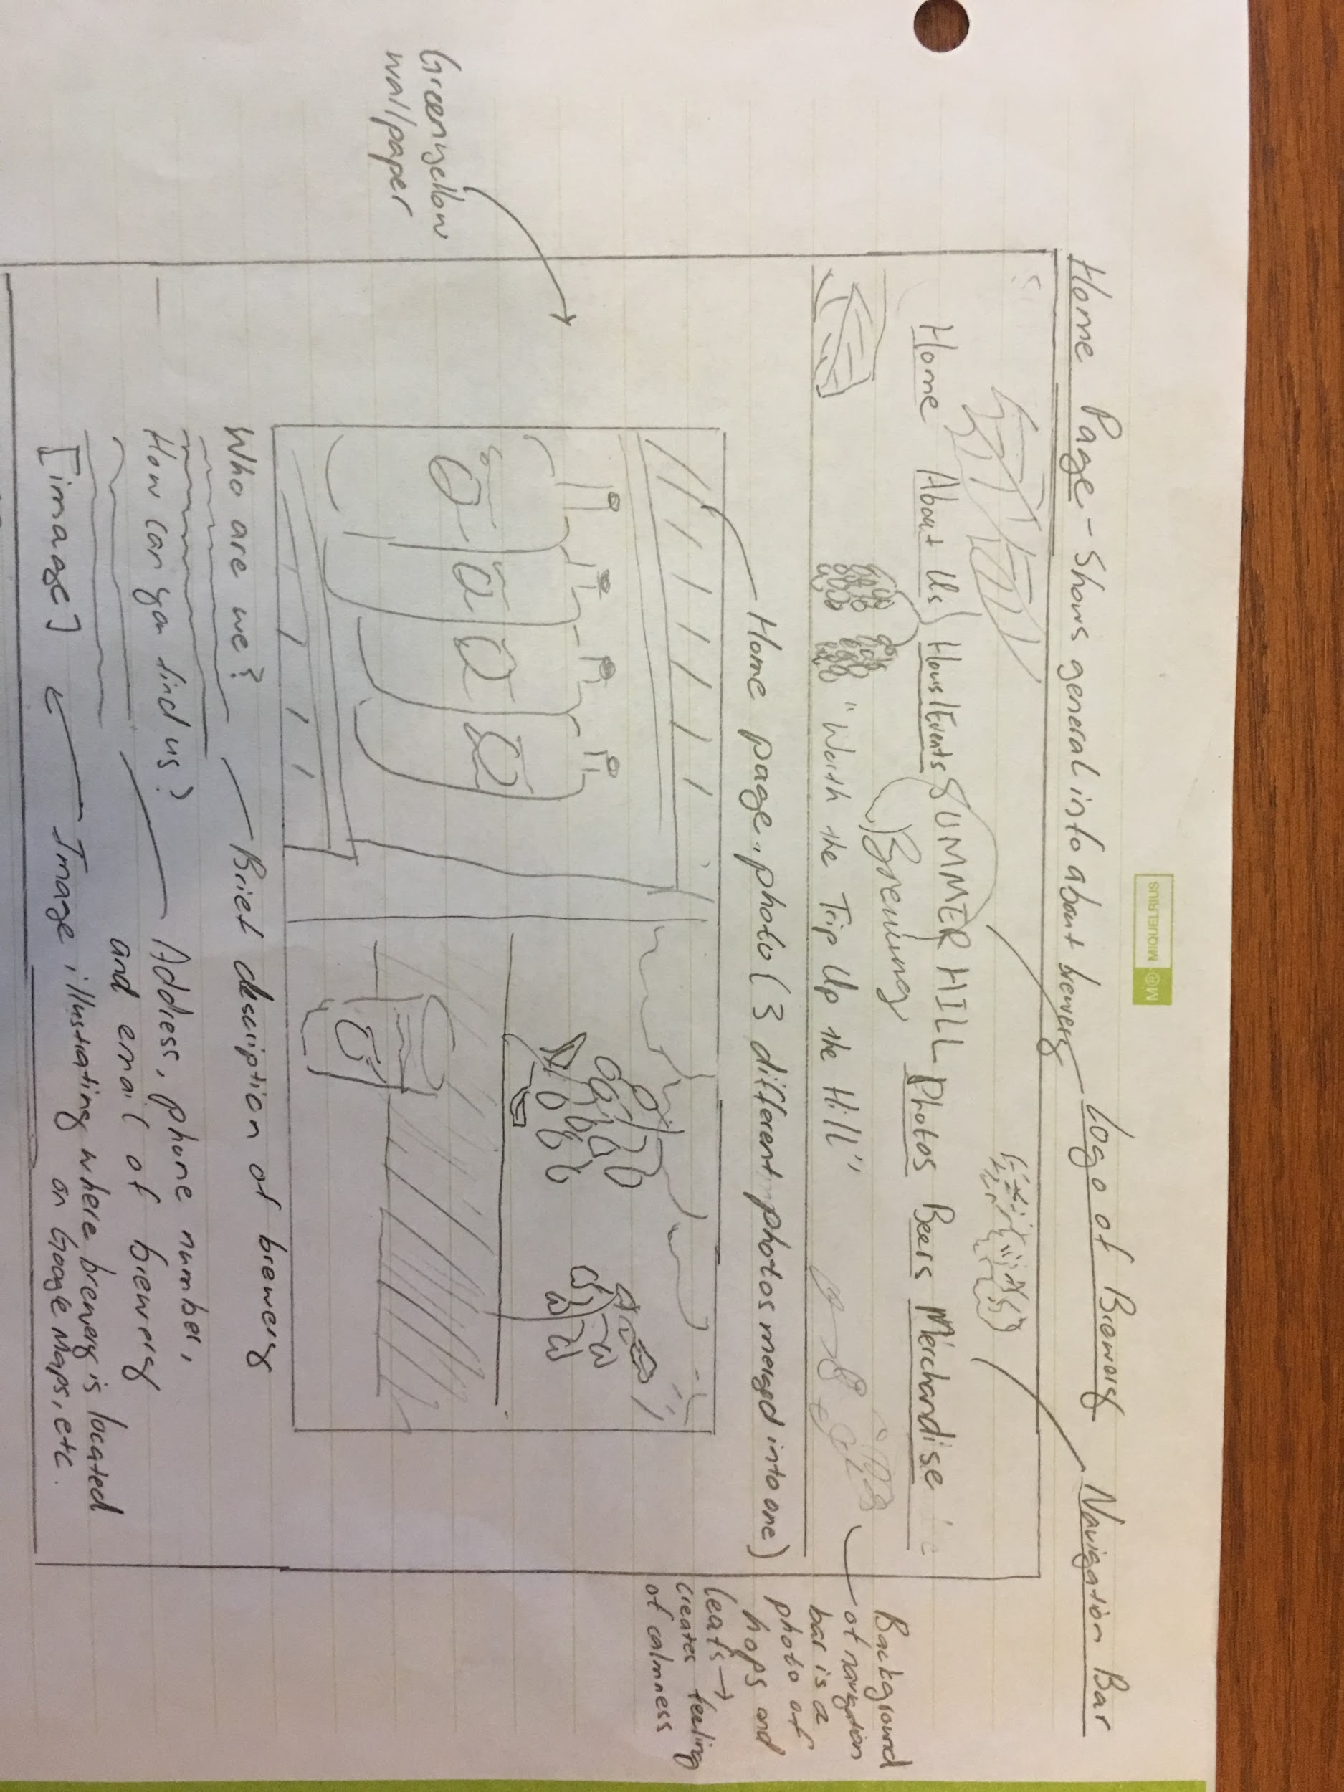

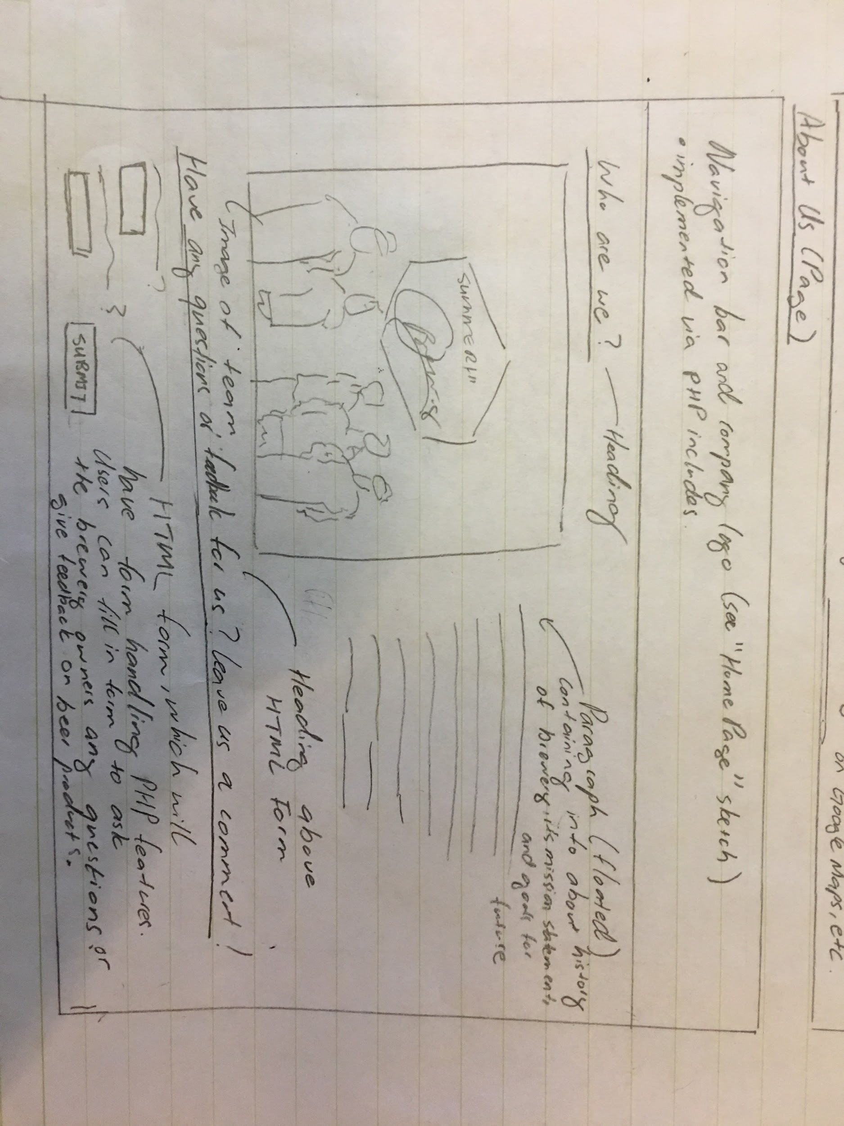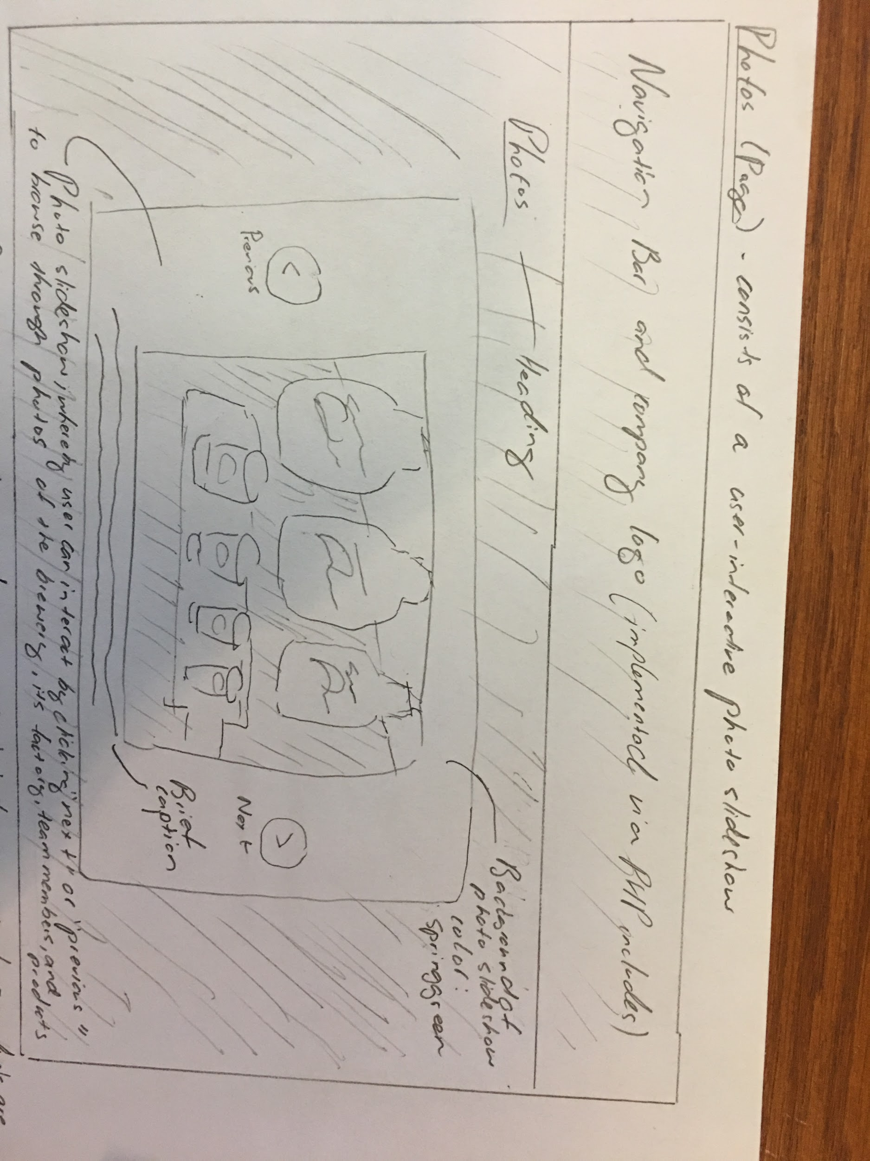

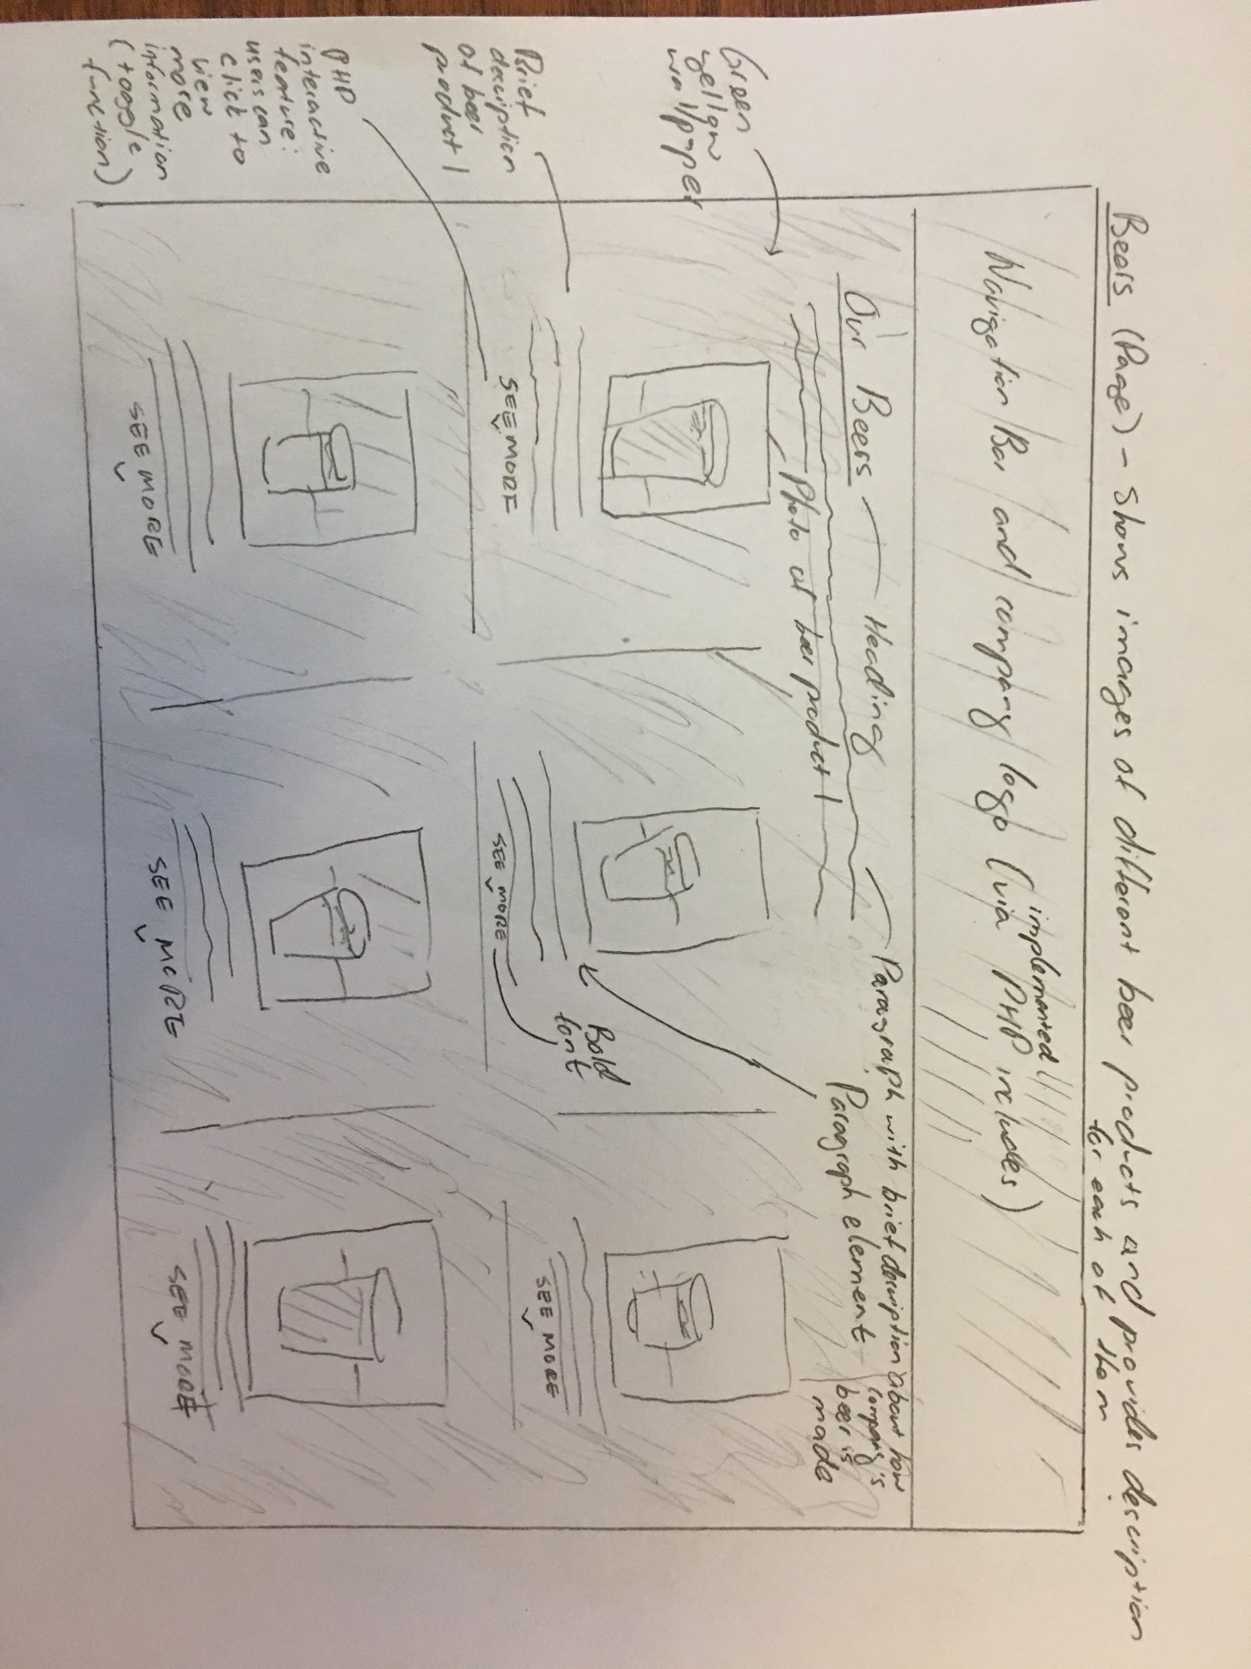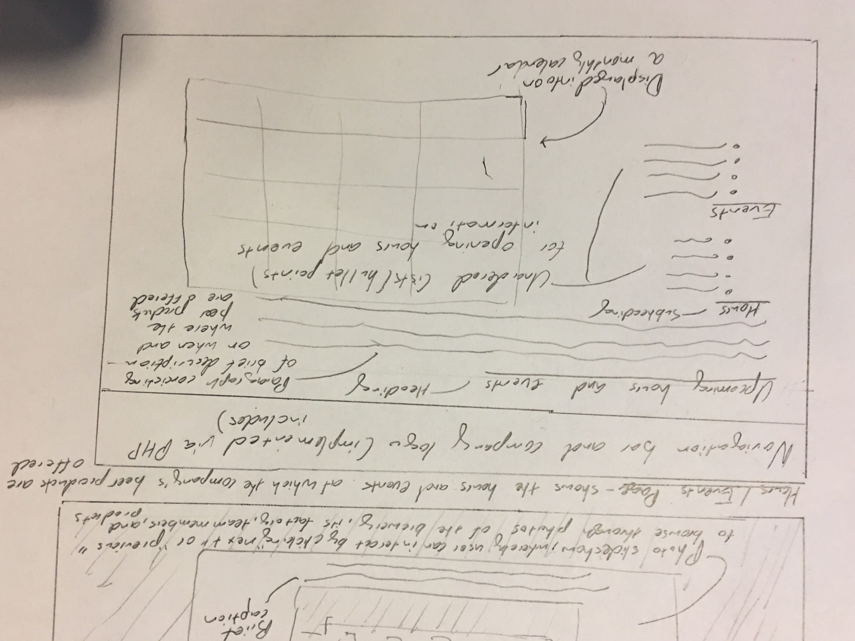

## **Milestone 1: Additional comments**

If you feel like you haven’t fully explained your design choices in the journey map for Milestone 1, or you want to explain some functions in your site (e.g., if you feel like you make a special design choice which might not meet the requirements), you can use this space to justify your design choices.